Instagram Account Compromise | Incident Report
Date: July 7th, 2025
By: Saadman Iqbal

- Executive Summary
*Note: Saskatoon, Saskatchewan, does not observe daylight saving time; thus, the UTC to CST offset at the time of the incident was -7 hours*

On June 30th, 2025, the Instagram account, tsw_saadman, was compromised at 12:37:48 P.M. UTC. The attacker gained access to the entire Instagram account, including posts, chats, analytics, and account settings. The attacker proceeded to post 8 reels on the account promoting a webpage supposedly running a cryptocurrency phishing scam. The breach was limited to the Instagram account and did not compromise the devices used to access the account. The breach was contained at 6:26 A.M. CST via a password change and initiating a logout on all devices.

- Incident Details
  - Incident Type
Unauthorized Access – Account Takeover (use of stolen credentials)
NIST SP 800-61 r2/r3
  - Date and Time of Occurrence
Time of account compromise (unauthorized login): 2025-06-30T06:37:48-06:00
  - Date and Time of Detection
Notification of compromised account: 2025-06-30T05:05-06:00
Detection of compromised account by account user: 2025-06-30T05:38-06:00
  - Affected Systems/Data
Instagram account of tsw_saadman, including but not limited to account settings, chat logs, account activity (posts, likes, comments, shares, etc.)
Devices’ geographic locations that are logged into tsw_saadman
Reputation of account user
  - Incident Timeline
2025-06-30T10:37:48+00:00 – unauthorized account login from IPv6 address 2604:3d09:e186:9200:314c:8f44:5a6c:2d1d, located in Brampton, Ontario Canada
2025-06-30T11:05:00+00:00 - unauthorized change of profile privacy from private to public.
2025-06-30T11:05:00+00:00 to 2025-06-30T11:012:00+00:00 – a series of eight Instagram reel posts were uploaded to profile for public viewing
2025-06-30T11:27:00+00:00 – first detection of compromise by human, account viewer sent account holder a message stating the Instagram account was hacked.
2025-06-30T11:27:00+00:00 – first detection of compromise by human, account viewer sent account holder a message stating the Instagram account was hacked.
2025-06-30T12:07:00+00:00 – second detection of compromise by human, account viewer (separate from first detection)) sent account holder a message stating the Instagram account was compromised.
2025-06-30T12:23:00+00:00 – Account holder receives a call via an alternate account through Instagram stating account compromise.
2025-06-30T12:26:00+00:00 – Compromised Instagram account password changed, and Instagram is logged out of all devices except the device where the password change occurred
2025-06-30T12:28:00+00:00 – All unauthorized posts were deleted and stored in recently deleted section of Instagram profile, compromise fully resolved.

- Impact Assessment
  - Scope of Impact
The breach of the account led to only the Instagram account being impacted and nothing else. The devices of the accounts were not affected as the attacker did not seem to be interested in the logged in devices since they never requested an information download. On Instagram the primary types of data affected were the profile page, where unauthorized posts were made, as well as account settings, which was changed from a private account to a public account. Other features such as chat logs and post analytics may have been affected via unauthorized viewing, however there is no way to confirm this. There was no disruption of account functions since the authorized account user still had access on their device. Affected users include the account holder, via unauthorized posting and change of account settings, as well as all users whom the primary user had chat with, via unauthorized viewing of chat logs. The breach resulted in reputational damage. Multiple followers viewed the scam posts, which contained explicit content. This led to the loss of eight followers and concerns that the account owner had fallen victim to a scam.
  - Data Compromised
Plausible compromise of account chat logs, and account posting activity via unauthorized viewing. It cannot be confirmed whether the attacker accessed chat logs, though unauthorized viewing remains a possibility.
  - Operational Impact
No recorded operational impact, account users had full access to the Instagram account during the duration of the breach
  - Regulatory/Legal Impact
The unauthorized posts violated Instagram’s community guidelines due to their explicit nature. However, no formal regulatory consequences were recorded.

- Investigative Analysis
  - Information on the Attacker
The attacker logged in using the IPv6 address 2604:3d09:e186:9200:f4d8:53af:d0b4:8e57, originating from an iPhone running iOS 18.5 (device info may have been spoofed). An IP lookup placed the address in Toronto, Ontario, with Shaw Communications as the ISP. The address is not found on known blacklists, suggesting it is a legitimate IP and not generated by a VPN. The attacker was attempting to promote a scam to redirect potential viewers to flavbit.com.
Flavbit.com is a known cryptocurrency scam website that utilizes AI deepfakes to lure viewers to entering their credential information in hopes to get a reward of (X) amount of local currency in Bitcoin. It does so by stating that if the user applies a code, they are entitled to a sum of Bitcoin, however, to initiate the transaction a small bitcoin deposit is required, to where users enter their credential information. The scam itself operates under various domains such as bitsowex.com and bitxspark.com. The full information of the scam can be found in the link below.
https://malwaretips.com/blogs/flavbit-com-crypto-scam/
  - Investigative Steps for the Future
Due to jurisdictional limits and the minimal scope of compromise, further investigation was not pursued. The Impact Assessment of this incident does not warrant further involvement as compromised data was not significant, nor did the actions taken by the attacked impose a serious threat to use privacy.

- Incident Response
  - Containment Measures
The password of the compromised Instagram account was changed at 6:26 A.M. CST, and all other devices were forcibly logged out except for the one where the password change was performed. This containment is further proven by the logout activity.
  - Evidence Preservation
A downloadable data archive (zip) provided by Instagram served as the main source of forensic evidence, capturing activity from the time of detection to containment.

- Root Cause Analysis
  - Primary Cause
Using Malwarebytes, the account holder’s login information was leaked in a data breach, specifically the 40M ULP Combo list, which was leaked on June 29th, 2025, a day before the Instagram breach. Therefore, on June 29th, 2025, the account holder likely entered their email-password combination into a phishing website prior to the breach. However, without access to the 40M ULP Combolist, finding which specific website these detailed were entered into remains inconclusive.
  - Contributing Factors
The primary contributing factor to this breach was the user utilizing the same username and password combo for many different logins. As a result, if one login was breached, it meant that multiple logins were also breached.

  - Recommendations
    - Immediate Actions
Immediate actions were to change the password for the compromised Instagram account and initiate and a logout of all devices command to logout the attacker from the breached Instagram account.
    - Improvements
The same username and password combo was not only used on Instagram but also other platforms such as Steams, Riot Games, etc. Therefore, a short-term improvement was to go change the passwords to unique and independent ones to further prevent multiple login breaches if in the future an account was compromised.
It is suggested to store all these unique passwords into a secure document, preferably one that is saved onto a local device’s hard drive without internet capabilities. This is to remember all the passwords for each unique login and to further secure these passwords to ensure no remote breach can occur. It is also recommended to passwords lock this document in the event of a local breach.

- Appendices of Relevant Evidence
  - Screenshot of first unauthorized login attempt
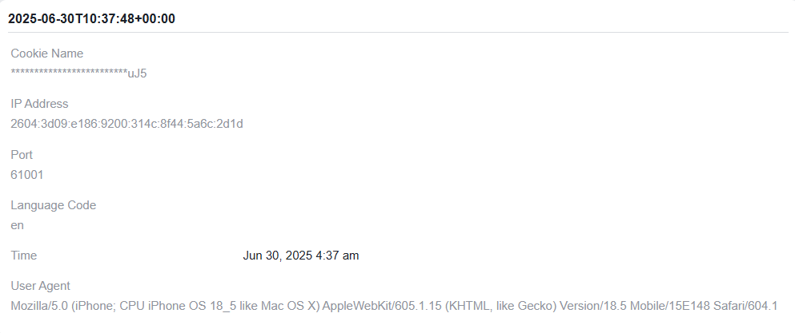
  - Evidence of logout activity from unauthorized devices
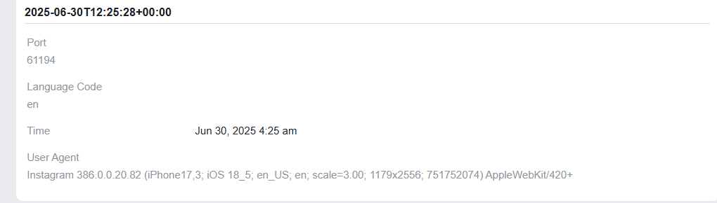

  - Screenshot of one scam reel redirecting to flavbit.com

  - Malwarebytes breach alert showing presence in a 40M ULP Combolist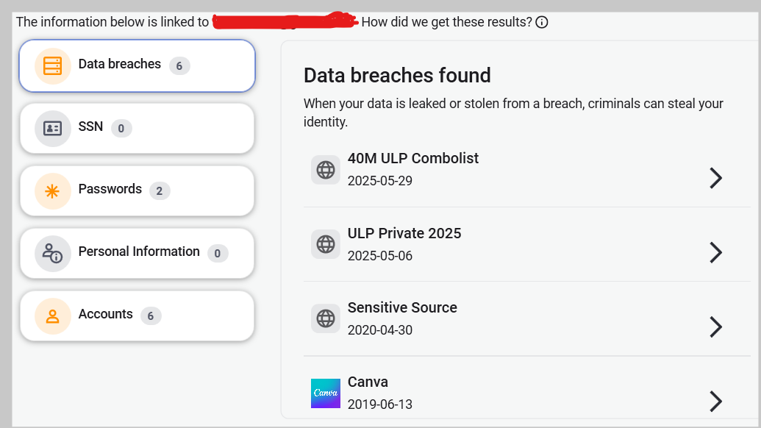

Report Prepared by Saadman Iqbal, on July 4th, 2025

